Вводный урок 13+ после сокращения
Как читать. Каждая тема чек-листа проверяется 1–2 раза. «Назвать предмет» даёт балл, только если слово само из темы (мяч → Sports; паспорт к теме Countries не относится — её проверяют флаг и вопрос). Сортировка и «соедини пары» — одно задание: по теме считается раз. Верный вариант — зелёный, на экране варианты перемешаны. Справа серым — тема чек-листа. На экране ученика — только короткая инструкция по-английски; русский заголовок задания — для учителя, он в плане.
Начало урока: Welcome to WowSpeak School! → знакомство, три вопроса по одной карточке (What’s your name? How old are you? What do you like doing in your free time?) → учитель рассказывает историю квеста → комната 1.

Часть 1 · Гостиная (уровень A1.1–A1.2)

1. Семейная фотография
Назвать: What's this? → a family photo без балла
Задание 1. Семья Тома на экране: Look and choose.
[картинка: семейное дерево — соберу из портретов, покажу превью]
1) Bob is Emma’s ___ . — uncle / father / grandfather Families
2) Mark and Kate ___ Tom’s parents. — are / is / am To be
Картинка — новое семейное дерево схемой: George ═ Rose → их сыновья Mark и Bob; Mark ═ Kate → Tom и Emma; Bob ═ Lily. Под портретами только имена.
And you? Tell me about your family. Families, To be
→ кусочек записки

2. Рюкзак
Назвать: What's this? → a schoolbag (a backpack) School objects
Задание 1. Что в рюкзаке у Тома на экране: Look and choose.
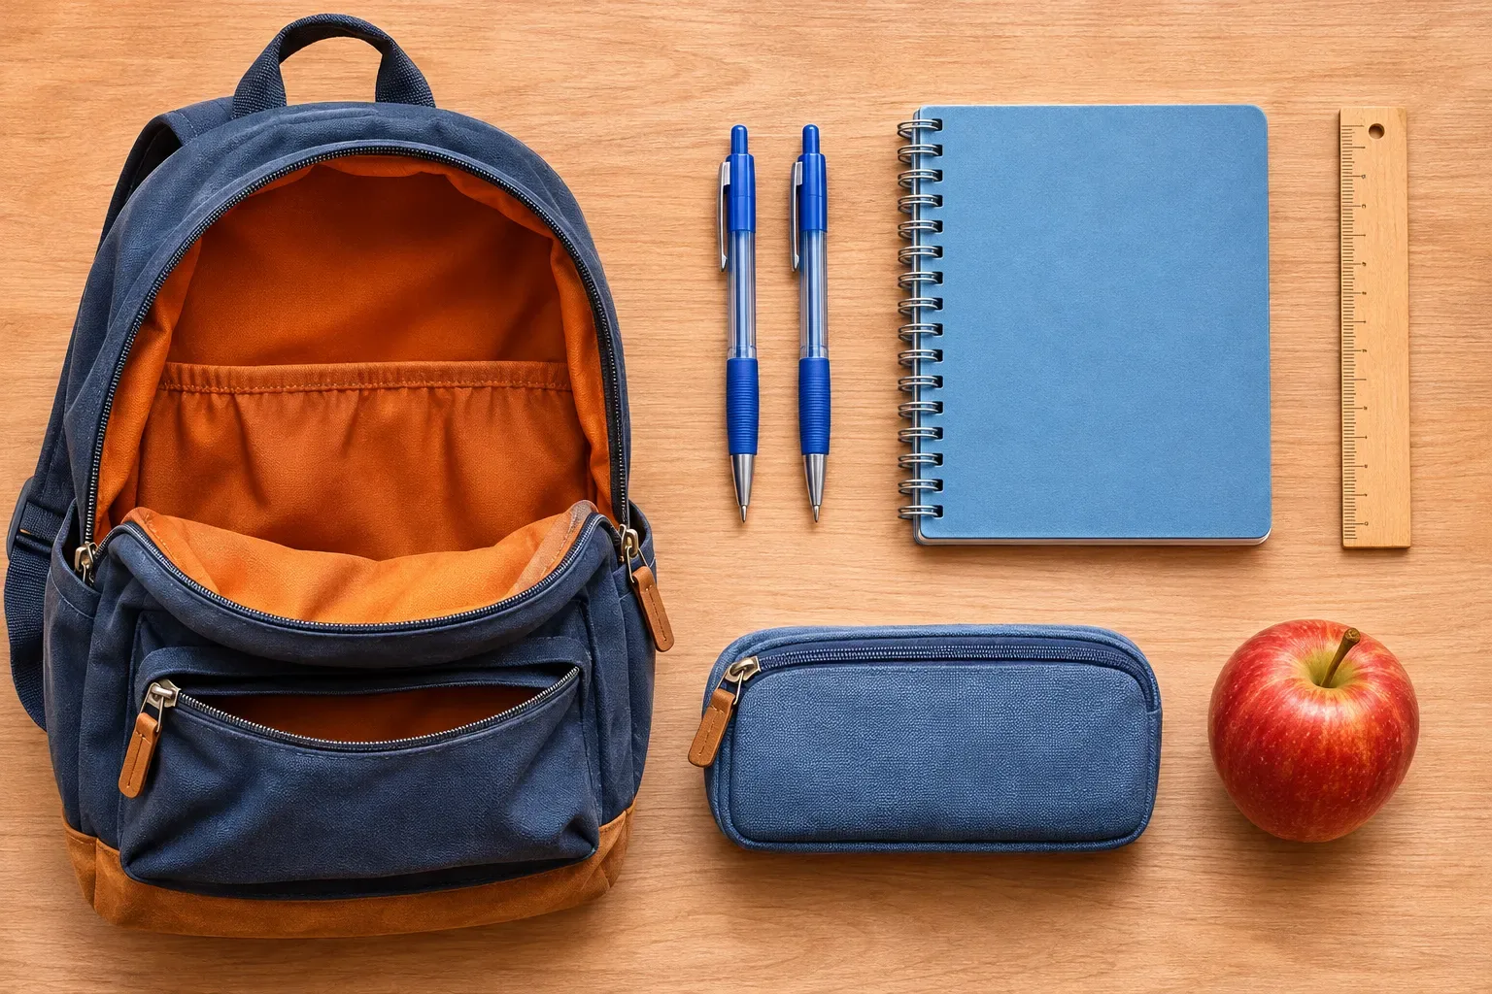
1) There ___ two pens. — are / is / am There is
2) There ___ a calculator. — isn’t / aren’t / is There is
3) Tom ___ got a pencil case. — has / have / is Have got
And you? What have you got in your school bag? School objects, Have got
→ кусочек записки

3. Паспорт
Назвать: What's this? → a passport без балла
Задание 1. Паспорт друга Тома на экране: Look at the flag and choose.
1) 🇩🇪 Hans is from Germany. He’s ___ . — German / Germany / Germanish Countries
And you? Where are you from? Which country would you like to visit? Countries
→ кусочек записки

4. Ваза с фруктами
Назвать: What's this? → fruit (a bowl of fruit) Food and drinks
Задание 1. Что в холодильнике у Тома на экране: Look and choose.
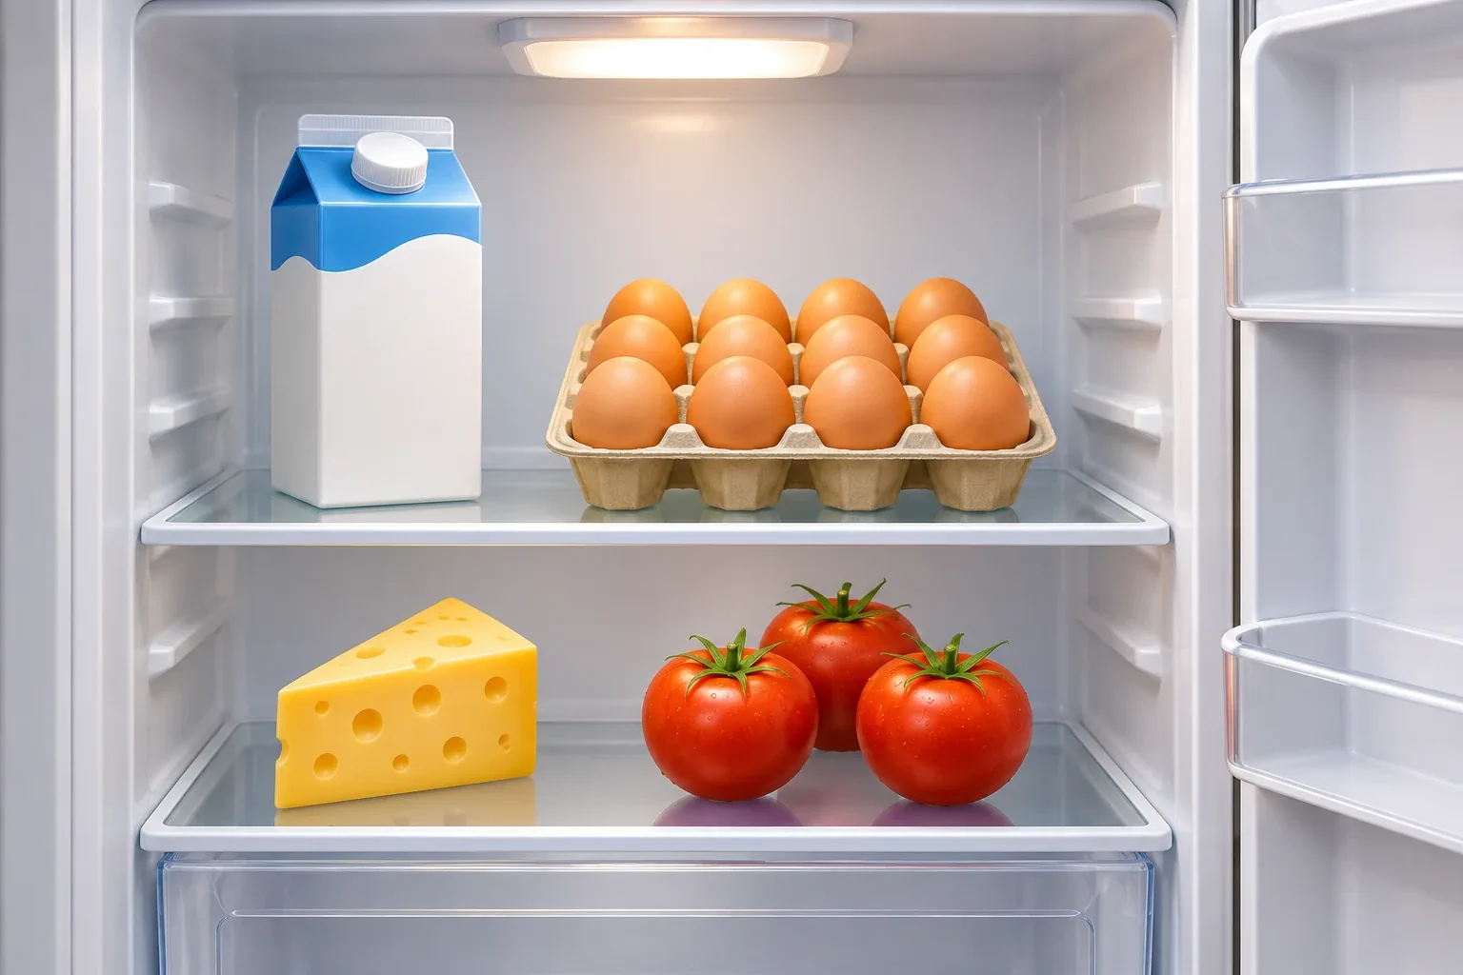
1) There is ___ milk in the fridge. — some / any / a Some, any, lots of
2) There aren’t ___ apples in the fridge. — any / some / a Some, any, lots of
Было «верно / неверно» на 6 пунктов — ответ был виден по картинке без грамматики.
And you? What do you usually have for breakfast? Food and drinks
→ кусочек записки

5. Футбольный мяч
Назвать: What's this? → a football (a ball) Sports
Задание 1. Том играет в футбол на экране: Look and choose one word.
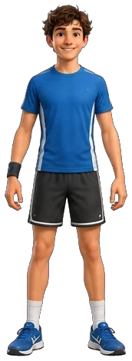
1) стрелка на колено — knee / foot / leg / arm Body parts
2) стрелка на ступню — foot / knee / leg / arm Body parts
Было пять стрелок, стало две.
Задание 2. Какой спорт любит Том на экране: Look and choose.
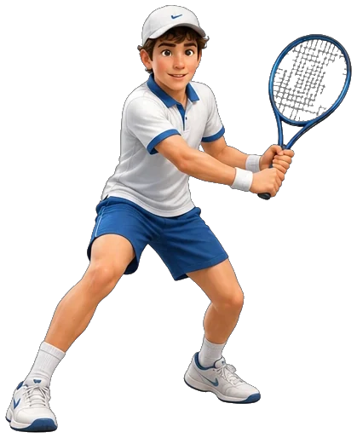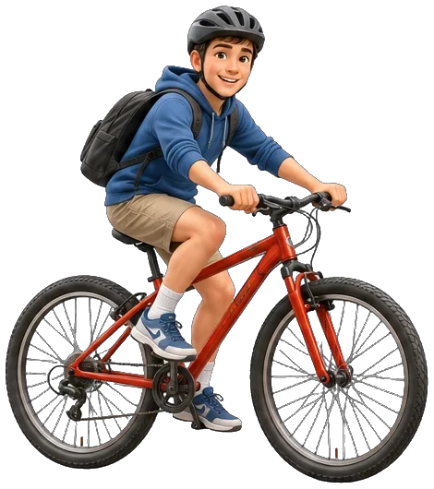
1) Tom ___ tennis every Saturday. — plays / play / playing Present Simple
2) ___ Tom ride a bike to school? — Yes, he does. — Does / Do / Is Present Simple
3) Tom can play tennis, but he ___ play basketball. — can’t / can / don’t can Can/Can’t
Теннисную ракетку перерезать (замечание 13).
And you? What sports can you do? Sports, Can/Can’t
→ кусочек записки

6. Игрушечный автобус
Назвать: What's this? → a bus Transport
Задание 1. Вид из окна — устно на экране: Who can you see? What do they do?
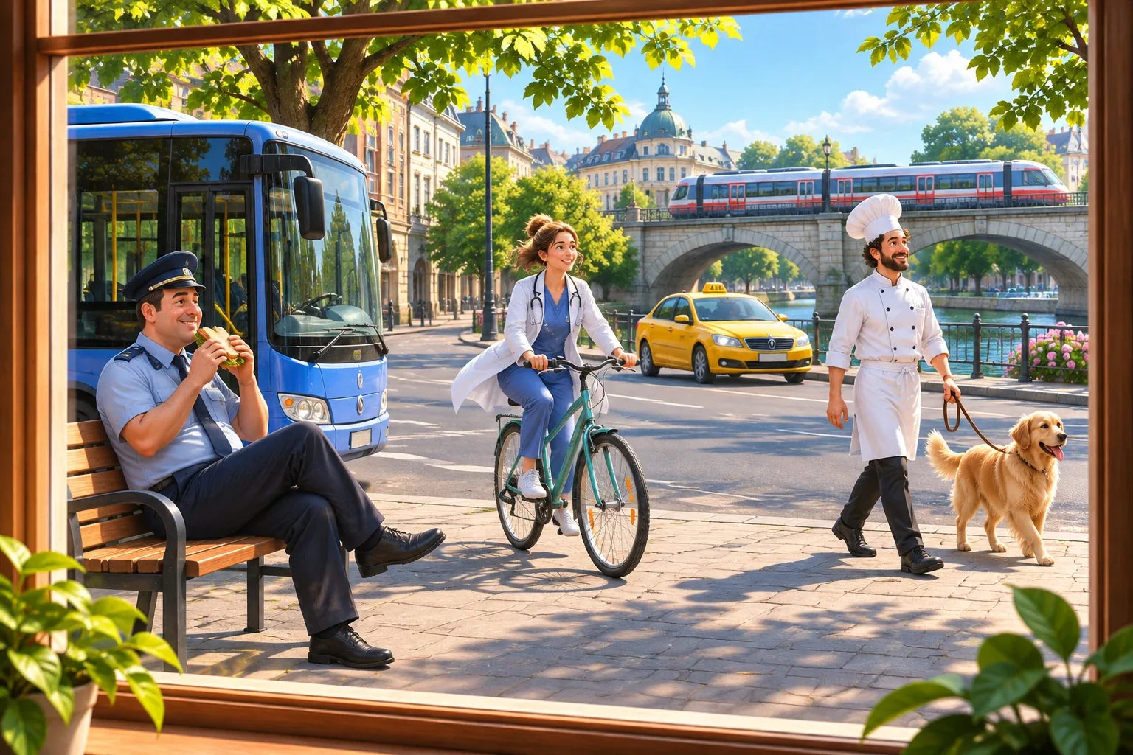
1) Ученик называет людей и профессии: a police officer, a doctor, a chef… Jobs (учитель ставит балл)
Вариантов нет — учитель спрашивает и отмечает, сколько профессий назвал ученик.
Задание 2. Та же картинка на экране: Look and choose.
1) Look! He ___ a sandwich now. — is eating / eats / eat Present Simple vs Present Continuous
2) What’s on the bridge? — a train / a taxi / a bus Transport
And you? What are you doing now? Present Simple vs Present Continuous
→ кусочек записки

7. Билеты в кино
Назвать: What are these? → cinema tickets Entertainment
Задание 1. Собери предложение на экране: Put the words in order.
1) I always go to the cinema on Fridays. Adverbs of frequency
Задание 2. Выбери ответ на экране: Choose the right answer.
1) Let’s ___ to the cinema tonight! — go / going / to go Let’s…
And you? How often do you go to the cinema? What are your favourite places in your city? Adverbs of frequency, Entertainment
→ кусочек записки

8. Зонтик
Назвать: What's this? → an umbrella без балла
Задание 1. Какая погода — устно на экране: What’s the weather like?

1) Ученик отвечает сам: It’s snowy. / It’s cold. Weather (учитель ставит балл)
Вариантов нет. Облако со снегом перерезать (замечание 13).
Задание 2. Едем на море: солнечно и жарко на экране: What do you take? Sort.
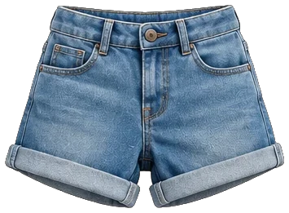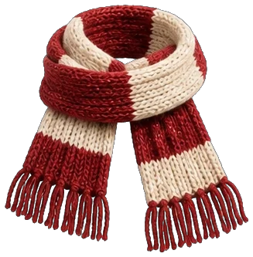
1) Take ✅: shorts, a T-shirt · Don’t take ❌: a jacket, a scarf Clothes
Четыре картинки без подписей. Ученик раскладывает и называет каждую вещь вслух (в плане). Футболку и куртку нарисовать (промпт в чате).
Задание 3. Выбери слово на экране: Choose the right word.
1) It’s sunny today. Tom ___ to go to the beach! — wants / want / wantes Need, want
Варианты по образцу goes / go / gos — уточняю у вас.
And you? What’s the weather like today? What do you need for a trip to the mountains? Weather, Need, want, Clothes
→ кусочек записки

9. Кошка
Назвать: What's this? → a cat Pets and farm animals
Задание 1. Животные на экране: Look and choose.
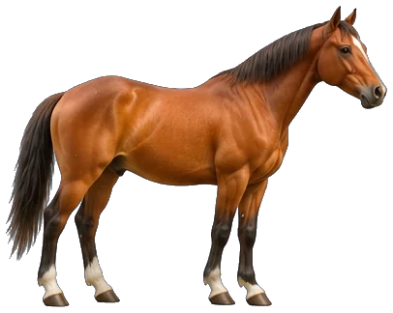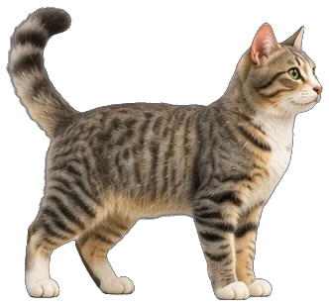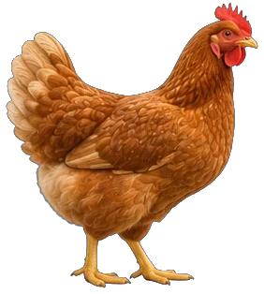
1) (лошадь и кошка) A horse is ___ than a cat. — bigger / big / biggest Comparatives
2) (тигр и кошка) A tiger is ___ than a cat. — more dangerous / dangerouser / most dangerous Comparatives
3) (корова, свинья, курица) Which animal gives us milk? — a cow / a pig / a chicken Pets and farm animals
Вёрстку переделать: картинки животных крупно (замечание 20). Тигра нарисовать (промпт в чате).
Задание 2. Голосовое сообщение на экране: Listen and choose.
1) What did Tom ride? — a horse / a bike / a bus Past Simple
2) Did he see the pigs? — No, he didn’t. / Yes, he did. / No, he don’t. Past Simple
3) What did they do in the evening? — They watched a film. / They played football. / They went to bed. Past Simple
Все три вопроса сразу на одном экране.
Текст записи: This is Tom. Yesterday he went to his grandparents’ farm. In the morning he fed the chickens and the sheep. Then he rode a horse! He didn’t see the pigs, because they were asleep. In the evening they had a big dinner and watched a film. It was a great day!
And you? What did you do last weekend? Past Simple
→ кусочек записки
Записка собрана → код (4 цифры). Экран с кодом: «Open the lock» — закончить урок, «Keep looking» — следующая часть.

Часть 2 · Тайный кабинет (уровень A2.1–B1.1)

1. Шкаф
Назвать: What's this? Describe it. → a big wooden wardrobe Household and furniture, Adjectives to describe objects
Задание 1. Спальня или кухня на экране: Sort the pictures. Name them.
1) Bedroom: a bed, a chest of drawers · Kitchen: a fridge, a cooker Household and furniture
Четыре картинки без подписей: ученик раскладывает и называет каждую вещь. Одежду здесь не проверяем — она была в части 1. Картинки нарисовать (промпт в чате).
Задание 2. Загляни в шкаф на экране: Choose the right word.
1) There aren’t ___ clothes in the wardrobe. — many / much / a Quantifiers
2) My sister keeps ___ shoes in this wardrobe — more than fifty pairs! — a lot of / much / any Quantifiers
And you? Describe your room. Adjectives to describe objects
→ кусочек записки

2. Чемодан
Назвать: What's this? → a suitcase Holidays
Задание 1. Как себя чувствовала Mia на экране: Look. How did Mia feel?

1) At the castle she was ___ . — excited / bored / angry Emotions
Задание 2. Рассказ Mia: найди ошибку на экране: Right or wrong? Correct the mistakes.
1) Last summer we goed to Spain. → went — ✘ False / ✔ True Past Simple
2) Look at this photo! Here I take a photo of the castle. → I’m taking — ✘ False / ✔ True Present Simple vs Present Continuous
And you? Tell me about your best trip. Where did you go? How did you feel? Holidays, Past Simple, Emotions
→ кусочек записки

3. Карта
Назвать: What's this? → a map Geographical features
Задание 1. Соедини слова с картинками на экране: Match the words and the pictures.
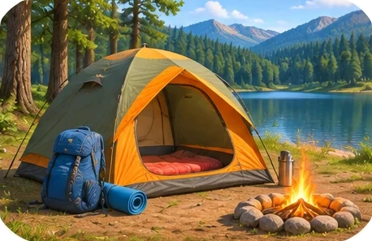
1) a river · an island · go sightseeing · go camping Geographical features, Travelling activities
Задание 2. Путешествие на экране: Choose the right answer.

1) We crossed the sea ___ . — by ferry / on foot / by bike Ways of travelling
2) Next summer we ___ climb these mountains. We’ve already bought the tickets. — are going to / might / will can Going to
3) I’m not sure, but I ___ go to Italy next year. — might / am going to / must Future with will, may, might
And you? What are you going to do this summer? Where would you like to travel? Going to, Travelling activities
→ кусочек записки

4. Аптечка
Назвать: What's this? → a first-aid kit Health and Illnesses
Задание 1. У врача на экране: Choose the right answer.
1) — What’s the matter? — I’ve got a ___ . I ate too much. — stomachache / stomach / hurt Health and Illnesses
2) I fell off my bike and now my ___ hurts. I can’t walk. — ankle / elbow / chin Body parts
3) You ___ stay in bed for two days. — must / mustn’t / don’t have to Must, have to
4) It’s Saturday tomorrow — you ___ go to school. — don’t have to / have to / mustn’t to Have to / don’t have to
And you? What do you have to do at home? What must students do at your school? Have to / don’t have to, Must, have to
→ кусочек записки

5. Книга
Назвать: What's this? → a book (a novel) Free time activities: books and films
Задание 1. Отзыв о книге на экране: Choose the right answer.
1) This book ___ by a 15-year-old girl in 2010. — was written / wrote / is writing Passive
2) I love it! I ___ it three times. — have read / am reading / reads Present Perfect
3) Kate and Sam are best friends, but then they ___ in love. — fall / get / make Relationships
4) If you like adventures, you ___ love it. — will / would / are 1st Conditional
And you? What’s the best book or film you’ve ever read or seen? Present Perfect, Free time activities
→ кусочек записки

6. Плакат «Разыскивается»
Назвать: What's this? → a poster (a wanted poster) Crime and criminals
Задание 1. Голосовое сообщение: найди вора на экране: Listen and find the thief.
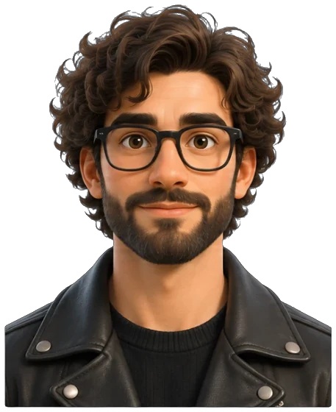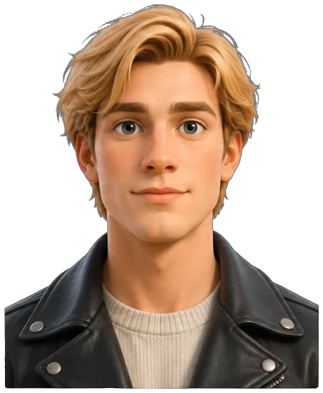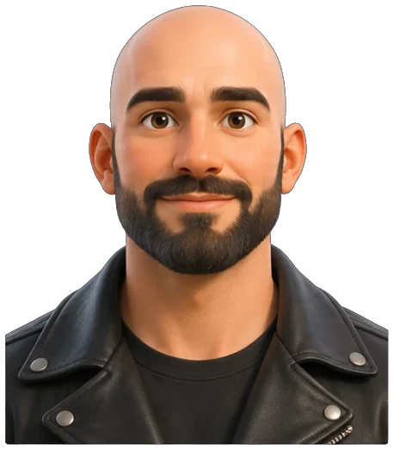
1) Who is the thief? (четыре портрета) Describing people
2) What did the thief steal? — a painting / some money / a phone Crime and criminals
3) What was he doing when the police arrived? — He was running to his car. / He runs to his car. / He is running to his car. Past Continuous
Все три вопроса сразу на одном экране.
Текст записи: Last night somebody broke into the museum and stole a famous painting. A witness saw the thief. He was tall, with curly dark hair and a beard, and he was wearing glasses and a black leather jacket. When the police arrived, he was running to his car.
Задание 2. Что было в музее на экране: Choose the right answer.
1) The thief ___ the painting when the alarm ___ . — was taking … rang / took … was ringing / was taking … was ringing Past Continuous vs Past Simple
Один вопрос с двумя пропусками.
And you? Describe someone in your family. What does he or she look like? Describing people
→ кусочек записки

7. Кошелёк
Назвать: What's this? → a wallet Money and shopping
Задание 1. Покупки на экране: Choose the right answer.
1) I ___ any new clothes for two years. — haven’t bought / didn’t buy / don’t buy Present Perfect vs Past Simple
2) I ___ my friends at the shopping centre at 5 tomorrow — it’s all arranged. — am meeting / meet / met Going to vs Present Continuous for future
And you? What are you doing this weekend? What did you buy last time you went shopping? Going to vs Present Continuous, Money and shopping
→ кусочек записки

8. Ноутбук
Назвать: What's this? → a laptop Computer phrases
Задание 1. Переписка в чате: найди и исправь ошибку на экране: Find the mistake and correct it.
1) Tom said that he is tired. → ошибка is, верно: was Reported speech
2) The boy which lives next door is my friend. → ошибка which, верно: who Relative clauses
В каждом предложении есть ошибка. Ученик нажимает на неверное слово (балл ставится сам) и говорит правильный вариант вслух.
And you? What do you usually do on your computer or phone? Computer phrases
→ кусочек записки

9. Бинокль
Назвать: What are these? → binoculars без балла
Задание 1. Еда в кафе напротив на экране: Match the words and the pictures.

1) spicy · sour · sweet · salty Food and drink adjectives
Задание 2. Выбери слово на экране: Choose the right word.
1) ___ at that bird! It’s huge! — Look / See / Watch Look, see, watch
2) If I had better binoculars, I ___ see the birds on that island. — would / will / am 2nd Conditional
And you? If you had binoculars, what would you like to watch? 2nd Conditional, Look, see, watch
→ кусочек записки
Записка собрана → код (2 цифры). Экран с кодом: «Open the lock» — закончить урок, «Keep looking» — следующая часть.

Часть 3 · Тайная лаборатория (уровень B1.2–B2.2)

1. Кубок
Назвать: What's this? What is it for? → a trophy Sport phrases
Задание 1. Наша команда на экране: Choose the best answer.
1) Would you like to ___ our tennis club? — join / enter / win Sport phrases
2) ___ is my favourite sport — I won this trophy last year. — Swimming / Swim / To swimming Ing forms
3) I’m really good at ___ penalties. — scoring / score / to score Ing forms
4) Nick ___ like snowboarding, but now he loves it. — didn’t use to / doesn’t used to / not used to Used to
And you? What did you use to do when you were a child that you don’t do now? Used to
→ кусочек записки

2. Стетоскоп
Назвать: What's this? What is it for? → a stethoscope без балла
Задание 1. У врача на экране: Choose the best answer.
1) I fell down the stairs and ___ my ankle. — sprained / coughed / sneezed Health verbs
2) You ___ go to bed earlier. You look really tired. — should / must to / have Modals of obligation and advice
And you? What should people do to stay healthy? What do you do? Modals of obligation and advice, Health verbs
→ кусочек записки

3. Микрофон
Назвать: What's this? What is it for? → a microphone без балла
Задание 1. Слова про музыку на экране: Match the words and the definitions.
1) lyrics — the words of a song · a band — a group of musicians who play together · an album — a collection of songs released together Music
And you? What kind of music do you listen to? Have you ever been to a concert? Music
→ кусочек записки

4. Смартфон
Назвать: What's this? What is it for? → a smartphone Social media
Задание 1. Голосовое сообщение на экране: Listen and choose.
1) What had Anna done before she suggested recording a video? — She had posted a photo online. / She had recorded a video. / She had met Jess at school. Past Perfect
2) What did Anna suggest? — recording a video together / going to the cinema / taking more photos Reporting verbs
3) Jess ___ Emma that Anna could be a great photographer. — told / said / spoke Verbs of communication
Все три вопроса сразу на одном экране.
Текст записи: Emma and Jess are best friends. Yesterday Emma saw a photo that Anna had posted online. Anna had taken it at sunset, and it was amazing. Jess had already seen it and had left a comment under it. She told Emma that Anna could be a great photographer. When Anna read the comments, she laughed and suggested recording a video together. Jess agreed, and they decided to meet on Sunday, because Jess doesn’t like putting things off.
Задание 2. Телефон Анны на экране: Choose the right answer.
1) Anna’s phone screen was broken, so ___ yesterday. — she had it repaired / she had repaired it / she have it repair Causative have
And you? Have you ever had something repaired or done for you? Causative have
→ кусочек записки

5. Шапочка выпускника
Назвать: What's this? What is it for? → a graduation cap Education
Задание 1. Школа и университет на экране: Choose the right answer.
1) Do you know where the exam room ___ ? — is / is it / does Question forms (complex)
2) Our school is believed ___ more than 200 years ago. — to have been built / to build / building Passive: complex forms
3) I get ___ really well with my classmates. — on / up / off Phrasal verbs for relationships
And you? Do you know what you would like to study in the future? Why? Education, Question forms (complex)
→ кусочек записки

6. Сейсмограф
Назвать: What's this? What is it for? → a seismograph Natural disasters
Задание 1. Соедини слова с картинками на экране: Match the words and the pictures.
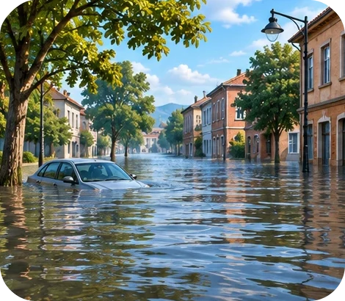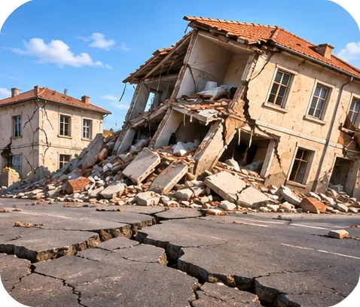
1) a volcanic eruption · a flood · an earthquake Natural disasters
Задание 2. Выбери ответ на экране: Choose the right answer.
1) When the volcano erupted, most people ___ escape in time. — were able to / could to / can Modals of ability and possibility
And you? What could you do to stay safe in an earthquake? Modals of ability and possibility
→ кусочек записки

7. Лупа
Назвать: What's this? What is it for? → a magnifying glass Crime and criminals
Задание 1. Место кражи на экране: Look and choose.

1) The broken glass is inside the room. The thief ___ through the window. — must have come / can’t have come / must come Modals of deduction in the past
2) “Where were you last night?” → The detective asked me where I ___ the night before. — had been / have been / was being Reported questions
3) “I didn’t take the money!” → The suspect ___ taking the money. — denied / admitted / suggested Reporting verbs
4) If the window had been locked, the thief ___ in. — wouldn’t have got / won’t get / didn’t get 3rd conditional
5) The owner always tells the truth. She is very ___ . — honest / selfish / lazy Personal qualities
6) A person who breaks into a house and steals things is a ___ . — burglar / witness / judge Crime and criminals
And you? What would you have done if you had been the detective? 3rd conditional
→ кусочек записки

8. Свиток
Назвать: What's this? What is it for? → a scroll History
Задание 1. Разложи слова на экране: Sort the words.
1) History: ancestor, century · Abstract nouns: freedom, honesty History, Abstract nouns
Задание 2. История свитка на экране: Choose the right answer.
1) An old man ___ along the beach when he found an ancient scroll. — was walking / walked / has walked Narrative tenses
2) When I was little, my grandfather ___ tell me stories about our ancestors. — would / will / was Present and past habits
And you? What did your grandparents use to do when they were young? Present and past habits
→ кусочек записки

9. Капсула времени
Назвать: What's this? What is it for? → a time capsule Hopes and dreams
Задание 1. Будущее на экране: Look and choose.

1) This time next week Mia ___ to London. — will be flying / will have flown / flies Future Continuous
2) By the end of the year they ___ from university. — will have graduated / will be graduate / graduated Future Perfect
And you? What do you hope to achieve by the end of this year? Hopes and dreams
→ кусочек записки

10. Рекламный щит
Назвать: What's this? What is it for? → a billboard Advertising
Задание 1. Разложи слова на экране: Sort the words.
1) Advertising: a slogan, a brand · Global issues: pollution, poverty · Online & media: a podcast, to stream Advertising, Global issues, Online and media
Задание 2. Слоганы: собери половинки на экране: Match the halves.
1) This new phone is great, but it costs … an arm and a leg. Idioms
2) Our new board game will help you break … the ice at any party! Idioms
3) The company could have chosen … a better slogan for this advert. Modals in the past
4) If I hadn’t seen that advert, … I wouldn’t be wearing these trainers now. 3rd and mixed conditionals
Задание 3. Артикли на экране: Choose a, an, the or —.
1) This is ___ best advert of the year! — the / a / — Determiners
2) It’s ___ advert for a new electric car. — an / a / the Determiners
And you? Have you ever bought something because of an advert? If you hadn’t seen it, would you have bought it? 3rd and mixed conditionals
→ кусочек записки
Записка собрана → код (2 цифры). Ученик читает код вслух → дверь открыта, финал.

